**Advanced Data Analytics**

**Week 5 Lectorial Exercises**

**Exercise 1**

For this exercise, you will be performing a **design critique** of 3 visualizations. Below are three different visual encodings of the same dataset (A, B, and C). State one disadvantage for each approach, analysing in terms of how the channels of length (horizontal), height (vertical), area (length x height of segments/bars), and colour are used to encode the attributes of water source (ground vs surface water), water usage, and population.

Also consider which tasks are best supported by each visualisation (focusing on the types of comparisons that are made easier or harder in each case).

**A. Water usage by source.** water use (area) = population (height) x per capita use (width).

Ordered by total water usage. Source: fao.org AQUASTAT. Dark grey - groundwater. Light grey - surface water. X-axis is litres per person per year.

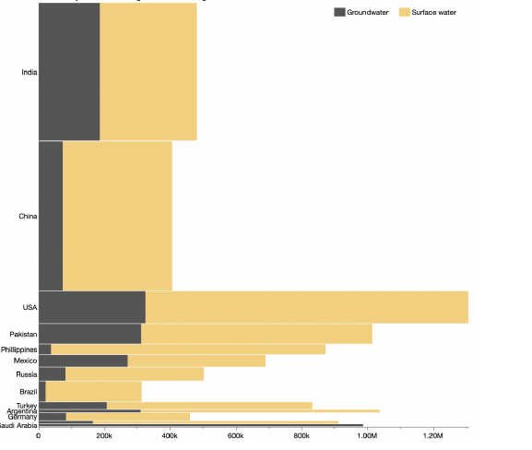

**B.** x-axis is percent of country’s usage. Row heights correspond to water usage for the whole country (not population).

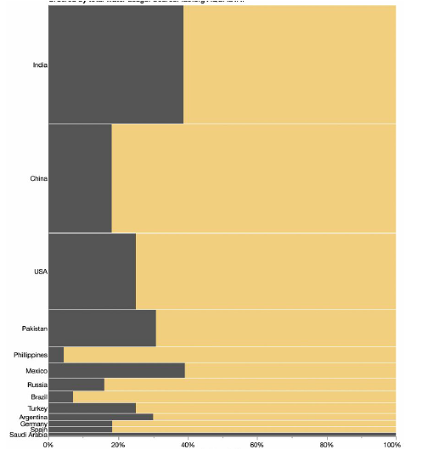

**C.**

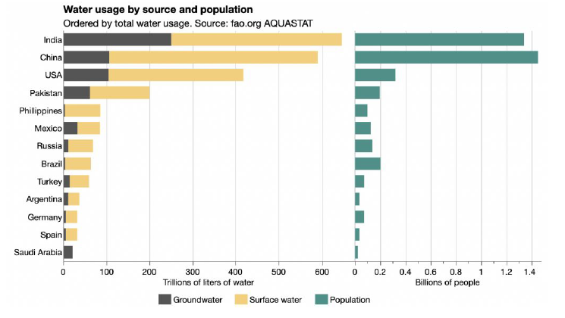

**Exercise 2**

1. What type of view coordination is used (single view, multiform, small multiples, overview/detail multiform, overview/detail same form)? Justify your choice very briefly in terms of whether the visual encoding is same or different, and whether data is shared between views or subsetted.
2. For each kind of mark used, state the mark type and which channels are used to encode what attribute on that mark.

Each small map represents a single state’s out-migrants, showing where in the US they moved. Darker grey indicates larger numbers of people moving. Black squares represent those who did not move.

